**Control system**

**Lab1**

|  |  |
| --- | --- |
| Name | Nada Tarek Mowafi |
| ID | 20012094 |
| Sec | 4 |

* **Part 1:Simulink:**
* 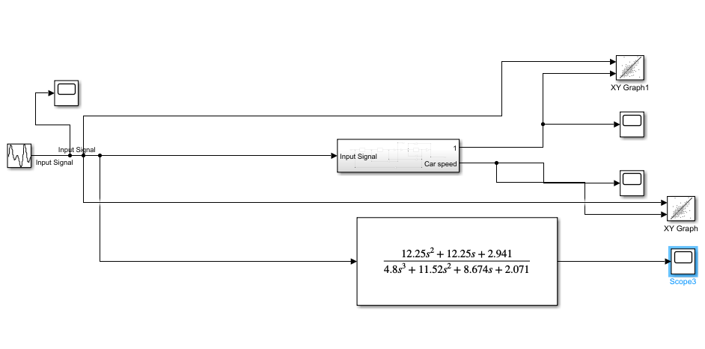**Develop a Simulink modle for the original system:**
* 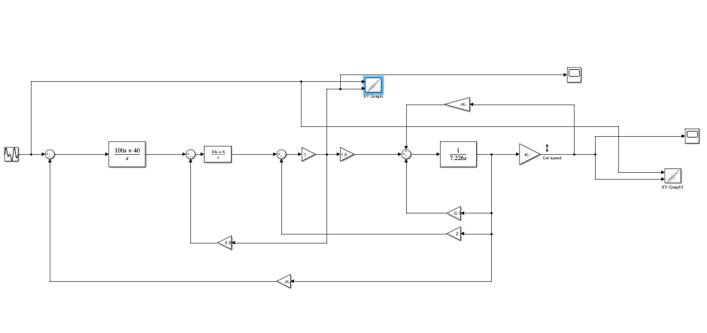**Inside subsystem:**
* **Input signal:**
* 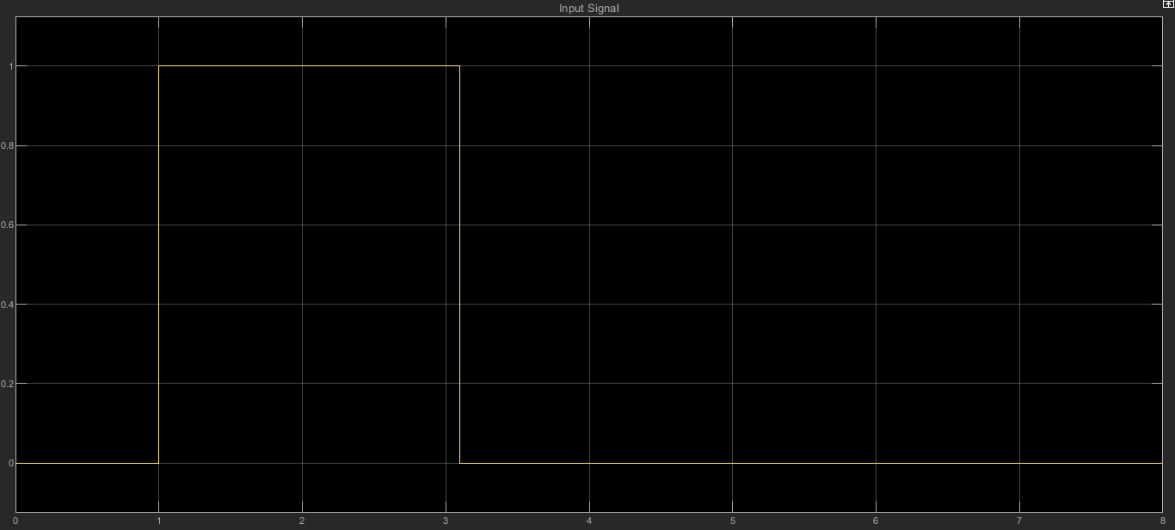**Pulse(1,1,2):**
* **Output scope(current):**

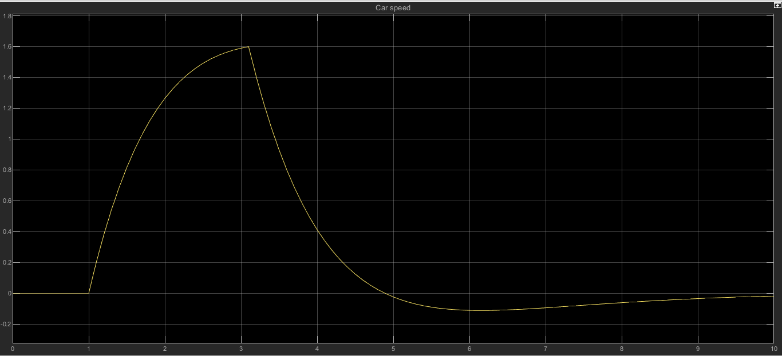

* **Output scope(armature):**

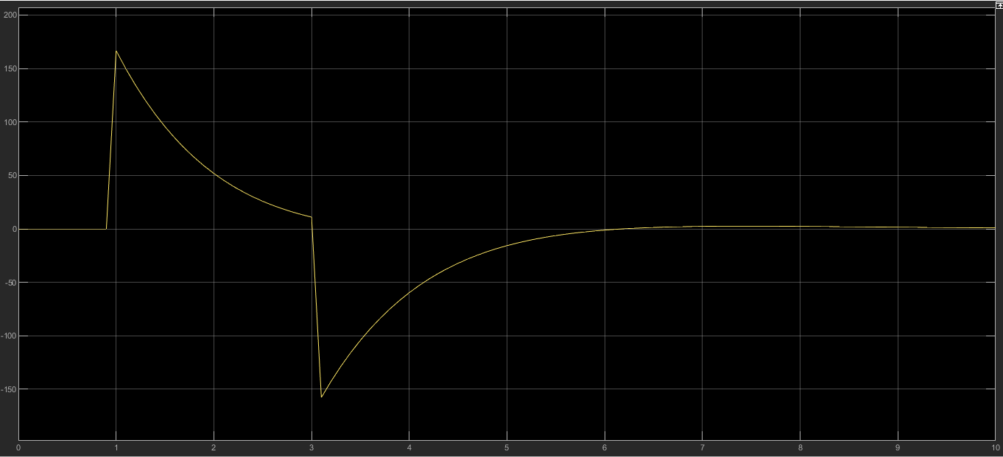

* **Xy graph:**
* **The xy graph (current):**

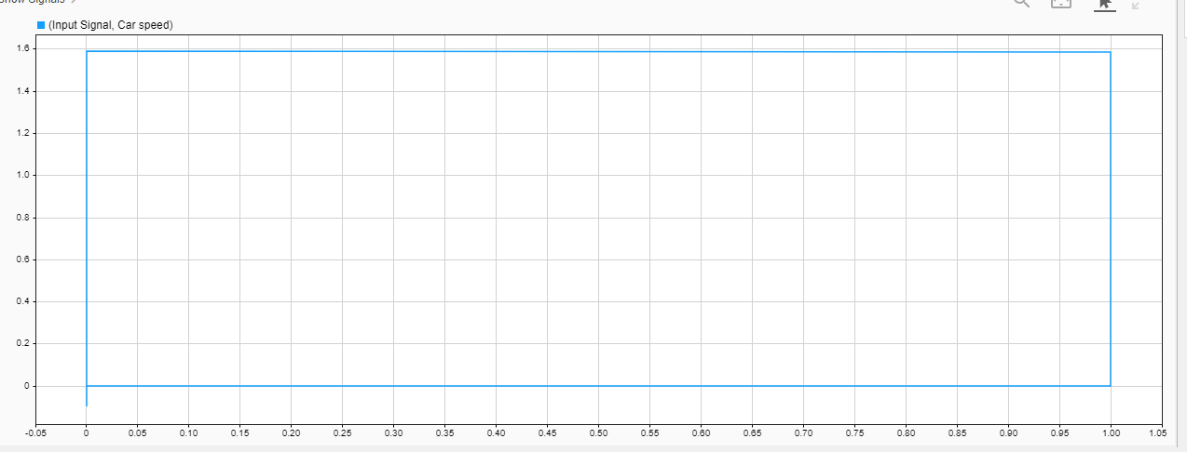

* 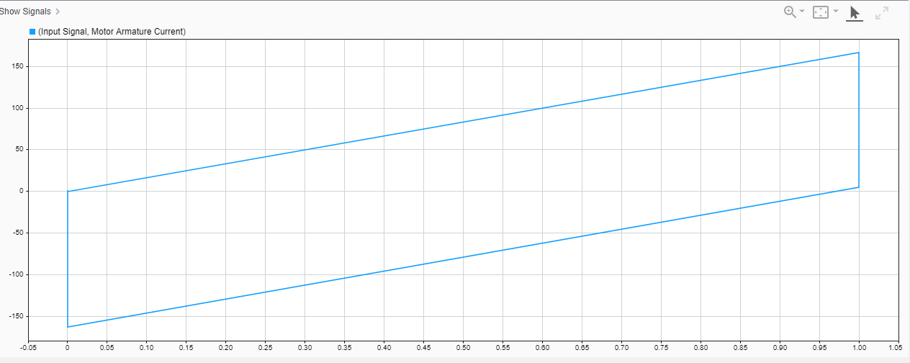**The xy graph (armature):**
* **Step response of the car speed and Step response of the motor armature current (A):**

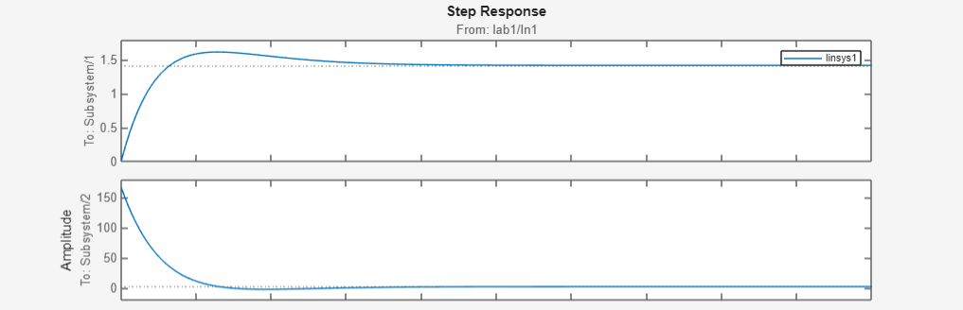

* 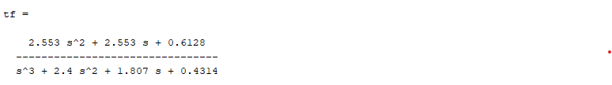**The transfer function using Simulink:**
* **Part2: MaTlab:**

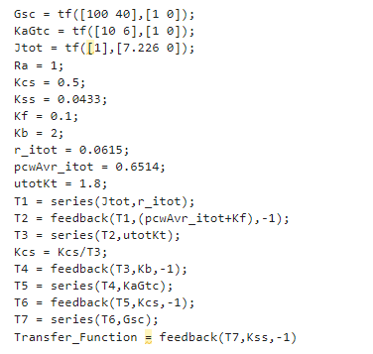

* **The equivalent transfer function :**

